10th Leeds Course in Operative Urology (COPU)

Littlewood Hall  Leeds General Infirmary  1-3rd March, 2018 | 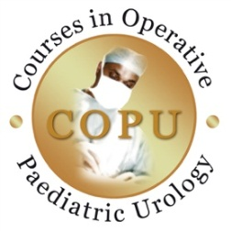

Sponsored by:

DAY ONE | DAY TWO
Hypospadias | VUR
- Live Operating

- Lectures and Video Demonstrations

- Robotic simulator (by appointment)

Fees: | COURSE (Thursday 1st – Friday 2n^{d} March)
 | Consultants | £100
 | Trainees | £80
 | Local trainees in other specialties – one day rate | Please email
 | ROBOTIC SIMULATION (Saturday 3rd March)  Only 25 places available; 45 minute session, Groups of 5  Strictly first come first served basis | £20

Delegate fee includes all refreshments (Thursday and Friday only) and Course Dinner (Friday evening) and free WiFi

REGISTRATION

PLEASE RETURN THIS FORM VIA EMAIL TO: joanne.haigh@nhs.net

Your details
Mr/Mrs/Ms/Dr/Professor
(please delete)
Other:
First name

Surname

Job Title/Programme of study

Organisation
Address

Postcode
Telephone

Email

Please specify any special access or dietary requirements

Payment
 | Consultant | Trainee
Course | £100 | £80
Robotic Simulation | £20 | £20
I will/will not be attending the course dinner (please delete) | Included | Included
Total

PLEASE SEND BANK TRANSFER TO:

Account Name: Leeds Teaching Hospitals Charitable Fund

Branch Sort Code: 56-00-54

Account Number: 23127554

Reference Number: (Paediatric Waterworks 5TA5)

IBAN Number: GB72NWBK56005423127554

SWIFT/BIC Number: NWBKGB2L

We will contact you to confirm registration

